**Hypothesis tests**

1. **Z test**

from scipy.stats import norm

import numpy as np

# Sample sizes

n1, n2 = 100, 120

# Means

x1, x2 = 6.2, 5.8

# Standard deviations

s1, s2 = 1.5, 1.2

z = (x1 - x2) / np.sqrt(s1**2/n1 + s2**2/n2)

p = 2 * (1 - norm.cdf(abs(z)))

print("Z-score:", z, "\nP-value:", p)

print("Significant difference" if p < 0.05 else "Not significant")

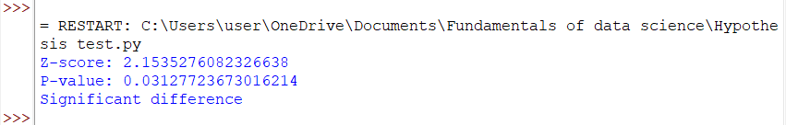

1. **T test**

import numpy as np

from scipy.stats import ttest_1samp

sample = np.array([20, 22, 19, 24, 21])

mu = 20

t_stat, p_val = ttest_1samp(sample, mu)

print("T-test: t =", t_stat, ", p =", p_val)

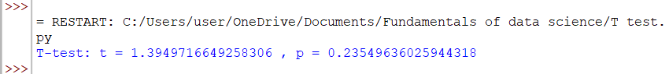

1. **F test**

from scipy.stats import f_oneway

group1 = [85, 86, 88]

group2 = [78, 76, 80]

group3 = [90, 92, 89]

f_stat, p_val = f_oneway(group1, group2, group3)

print("F-test (ANOVA): F =", f_stat, ", p =", p_val)

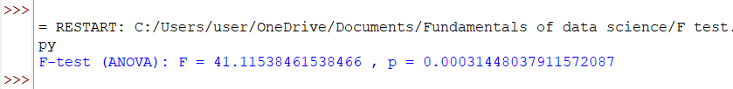

1. **Chi square test**

from scipy.stats import chi2_contingency

import numpy as np

# 2x2 table: rows = gender, columns = vote preference

data = np.array([[30, 10], [20, 40]])

chi2, p, dof, expected = chi2_contingency(data)

print("Chi-Square Test: χ² =", chi2, ", p =", p)

